Please email all nominations: awards@ansi.org

More information: ansi.org/awards

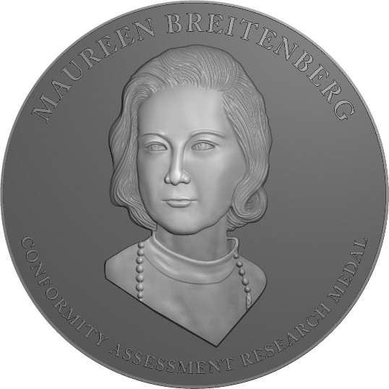 | Maureen Breitenberg  Conformity Assessment Research Medal  The Maureen Breitenberg Conformity Assessment Research Medal honors work that advances the principles of the National Technology Transfer and Advancement Act (NTTAA) through outstanding contributions toward reducing redundancy and complexity in conformity assessment. The award is named for Maureen Breitenberg, a valued leader and contributor to ANSI and the greater standards and conformity assessment community, who passed away in 2010. Ms. Breitenberg served as senior economist in the Standards Services Division of the National Institute of Standards and Technology (NIST). A prodigious author, her widely referenced publications on certification, conformity assessment, laboratory accreditation, and U.S. and international standardization activities have been recognized as primers for anyone entering these fields  Selection Criteria: Efforts to leverage private-sector conformity assessment infrastructure to meet market and regulatory needs, or distinguished research from business, industry, government, academic, or non-profit professionals that illuminate the importance of conformance in providing confidence in standards compliance, improving the health and safety of Americans, and strengthening the competitiveness of U.S. business in the global marketplace, will be considered.
Note: If, in the judgment of the Awards Committee, no candidates meet the eligibility requirements, an award may not be given. The Awards Committee reserves the right to present a nominee with an award other than the one for which they were nominated.

Nominee
Name

Employment Status | Please select
Title*
Organization*
Address
Telephone
Fax
E-mail

*Please include current information unless nominee is retired, then include most recent employer and job title.

Nomination Submitted by (Eligible Sponsor)*
Name
Title
Organization
Business address
Telephone
Fax
E-mail
*Nominations may be submitted by any member of the Institute; by members of any ANSI Board, committee council, or other group; or by members of an ANSI-accredited standards body, or an ANAB-accredited certifier. Nominations submitted with letters of support, the endorsement of a third party or an entire group are encouraged.
Sponsor’s Statement  of Authority | This nomination is being submitted on behalf of:  *  *If submitting on behalf of an employer or organization, please indicate that organization’s name below:
Electronic Signature | By checking the box shown at left, I confirm that I, my employer, or the organization that I represent qualify as an eligible sponsor as defined above. This mark constitutes my electronic signature endorsing the nomination contained herein.
Statement of Availability | By checking the box shown at left, I confirm that I (or another person designated by me) will be available to participate in the presentation of awards during a formal (black-tie optional) banquet and ceremony in Washington, DC, should the nominee identified on this form be selected.

Personal Statement from the Sponsor
Please include a short, PERSONAL STATEMENT (suitable for quotation in the nominee’s biography to the Awards Committee) explaining why you believe this candidate is deserving of the Breitenberg Medal. Please cite leadership characteristics and one or more specific accomplishments to support your statement.

Summary of Professional Background
Please provide a 100- to 200-word SUMMARY of the nominee’s professional background, roles and responsibilities in the areas of standardization, certification, or measurement, contributions to the international standards community, and other relevant factors supporting their eligibility for the Breitenberg Medal.

Letters of Support and Additional Information
Please include any additional relevant information of the nominee’s professional career. Letters of support from members of the standardization community attesting to the nominee’s outstanding achievements and appropriateness for receipt of the award are strongly encouraged (letters of support as well as a resume or curriculum vitae may be attached).

