Please email all nominations: awards@ansi.org

More information: ansi.org/awards

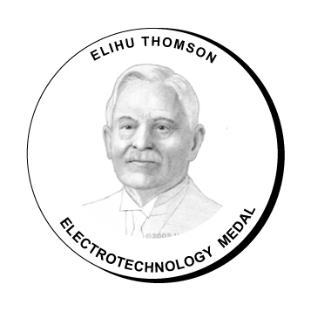 | Elihu Thomson Electrotechnology Medal  The Elihu Thomson Electrotechnology Medal honors an individual who has contributed in an exceptional, dedicated way to the field of electrotechnology standardization, conformity assessment and related activities both at the national and international levels.  The selection of a recipient for this medal will be primarily based on the individual’s leadership accomplishments within the electrotechnology standardization and/or conformity assessment field via the International Electrotechnical Commission (IEC), the U.S. National Committee of the IEC, and/or other such bodies.
Nominees shall have five or more years of involvement in such activities and shall meet one or more of the following criteria:

- The candidate played a major leadership role in the related technical area(s);
- The candidate made an outstanding technical contribution to the growth, development, promotion and improvement of electrotechnology standards and conformity assessment programs;
- The candidate was responsible for a related technical activity which had a significant impact on industry and/or commerce;
- The candidate has made a major contribution to the promotion of global electrotechnology standardization and conformity assessment programs in the business world;
- The candidate possesses a strong business ethic and is an extremely effective communicator, leader, contributor and worker.

Note: Only one Elihu Thomson Electrotechnology Medal may be awarded per year. If, in the judgment of the Awards Committee, no candidates meet the eligibility requirements, an award may not be given. The Awards Committee reserves the right to present a nominee with an award other than the one for which they were nominated.

Nominee
Name

Employment Status | Please select
Title*
Organization*
Address
Telephone
Fax
E-mail

*Please include current information unless nominee is retired, then include most recent employer and job title.

Nomination Submitted by (Eligible Sponsor)*
Name
Title
Organization
Business address
Telephone
Fax
E-mail
*Nominations may be submitted by any member of the Institute; by members of any ANSI Board, committee council, or other group; or by members of an ANSI-accredited standards body or an ANAB-accredited certifier. Nominations submitted with letters of support, the endorsement of a third party or an entire group are encouraged.

Sponsor’s Statement  of Authority | This nomination is being submitted on behalf of:  *  *If submitting on behalf of an employer or organization, please indicate that organization’s name below:
Electronic Signature | By checking the box shown at left, I confirm that I, my employer, or the organization that I represent qualify as an eligible sponsor as defined above. This mark constitutes my electronic signature endorsing the nomination contained herein.
Statement of Availability | By checking the box shown at left, I confirm that I (or another person designated by me) will be available to participate in the presentation of awards during a formal (black-tie optional) banquet and ceremony in Washington, DC, should the nominee identified on this form be selected.

Personal Statement from the Sponsor
Please include a short, PERSONAL STATEMENT (suitable for quotation in the nominee’s biography to the Awards Committee) explaining why you believe this candidate is deserving of the Elihu Thomson Electrotechnology Medal. Please cite leadership characteristics and one or more specific accomplishments to support your statement.

Summary of Professional Background
Please provide a 100- to 200-word SUMMARY of the nominee’s professional background, leadership accomplishments within the electrotechnology standards community and related conformity assessment activities (national, regional or international levels), contribution to the promotion of global electrotechnology standardization and conformity assessment programs, and other relevant factors supporting their eligibility for the Elihu Thomson Electrotechnology Medal.

Letters of Support and Additional Information
Please include any additional relevant information of the nominee’s professional career. Letters of support from members of the standardization community attesting to the nominee’s outstanding achievements and appropriateness for receipt of the award are strongly encouraged (letters of support as well as a resume or curriculum vitae may be attached).

